1. Create a new user registration form for a food delivery app (like Zomato) that saves user details (username, email, phone) to a MySQL database. After submitting the form, verify directly in the database that the new user record is created with correct values.
Ans:
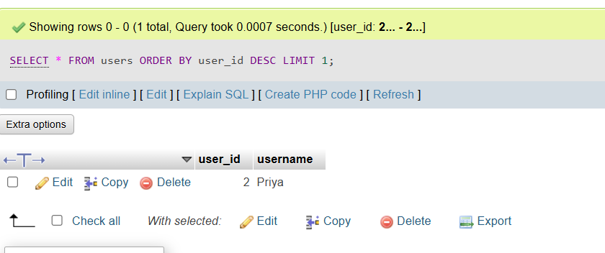

2. Given a table 'orders' in a Flipkart-style database with fields: order_id, user_id, item_name, quantity, and status, write SQL queries to validate that all orders with status 'delivered' have a non-zero quantity and item_name is not NULL.<br><br><em><strong>Hint:</strong> Use SELECT queries with WHERE conditions to check for invalid data.</em>
Ans:
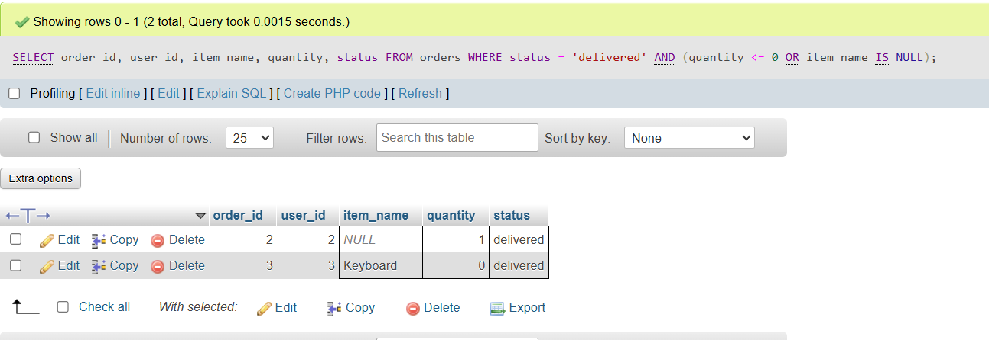

3. Compare the displayed user profile data in your app (name, email, mobile) with the actual data stored in the backend database for the same user. Report any mismatches you find between UI and database values.<br><br><em><strong>Hint:</strong> Change a value in the database manually, refresh the UI, and observe if the change is reflected or not.</em>
Ans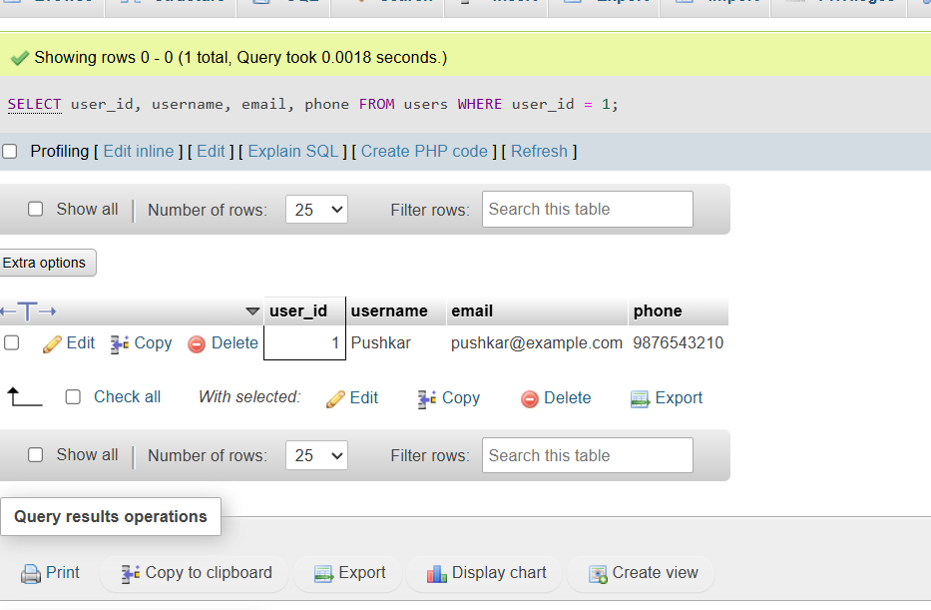

4. Perform field-level validation for a 'playlist' table (like Spotify) with fields: playlist_id, playlist_name, created_by, created_at. Check if any records have empty playlist_name or invalid created_at dates using SQL. Document your findings.
Ans:
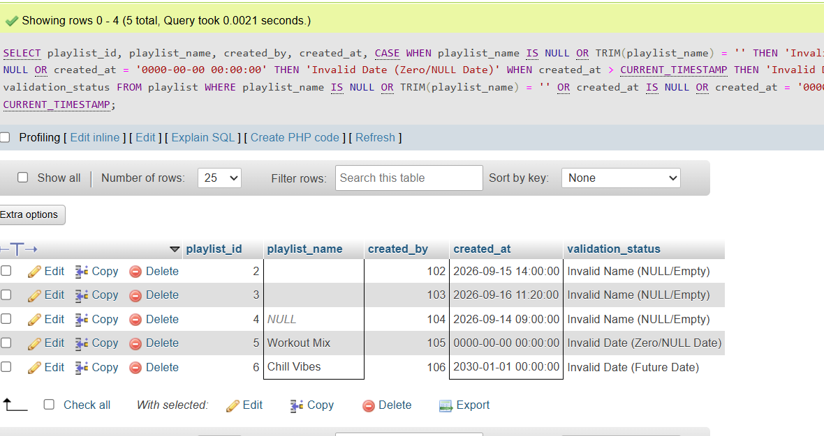

5. Explain with a practical example how the ACID properties (Atomicity, Consistency, Isolation, Durability) would apply when a user books a movie ticket on BookMyShow and the payment is processed. Give one line for each property.
Ans:
BookMyShow par movie ticket booking aur payment transaction ke dauran ACID properties is tarah apply hoti hain:

- Atomicity: Ticket booking aur payment ya toh dono poori tarah successful honge, ya fail hone par poora transaction rollback hokar paisa refund ho jayega (All or Nothing).

- Consistency: Transaction ke baad system state valid rahegi; seat ka status 'Available' se 'Booked' ho jayega aur double-booking jaisi invalid state allow nahi hogi.

- Isolation: Jab do users ek hi seat ko ek sath book karne ki koshish karte hain, toh unke transactions alag-alag process honge taaki kisi ko incorrect seat availability na dikhe.

- Durability: Ticket successfully book hone ke baad agar system crash ya server down bhi ho jaye, tab bhi booking details database me permanently saved rahengi.

